Why do gender gaps in political attitudes and voting change over time?

In this essay, I argue that gender gaps in political attitudes and voting have changed over time mainly due to the decline in female religiosity. Women used to be more religious and, because of that, more right-wing than men. But since the 1970s, the gender gap reversed as women became more left-wing than men. This coincided with the secularization of society, which was also stronger for women. First, I show the change from the traditional gender gap to the modern gender gap. Then, I examine the modernization thesis which claims that the change in the gender gap results from increased participation in education and the labour-force for women, and the decline of marriage and rise of divorce. But I argue that, although these factors might have contributed to the change in the gender gap, it is mostly the result of the decline in religion. Finally, I look at unexpected data for Radical Right Parties and at elite polarization.

Change in the gender gap

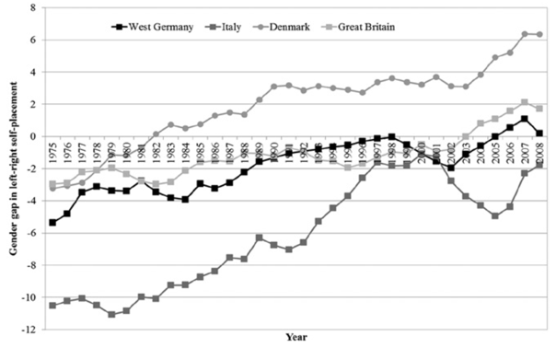
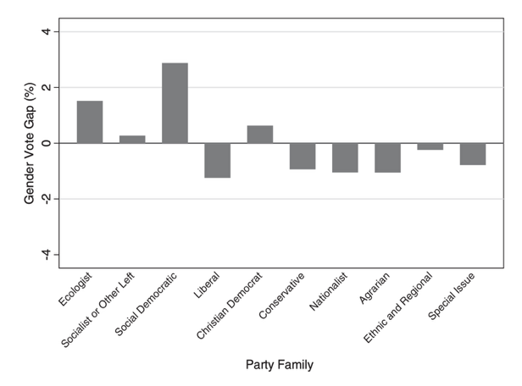
Traditionally, women voted more conservatively. Figure 1 shows that this gender gap (women’s left-right placement minus men’s left-right placement) used to be negative in Western democracies. Norris and Inglehart (2003) found that women were about 5-10 percent points more conservative than men in the 1950s-60s. However, since the 1970s, this gender gap has been reversing. By the 1980s-90s, women are about 3-6 percentage points more left-leaning than men. Women are now more supportive of redistribution, pro-environmental, pacifist, less nationalist and anti-immigration than men, and no longer as traditional on moral issues such as abortion or gay marriage. Consequently, women are now more likely to vote for parties in the Green and Social Democratic party family, and less likely to vote for Liberal, Conservative, and Nationalist parties. Still, women are more likely to vote for Christian Democratic parties (Shorrocks 2021).
Figure 1: gender gap in left-right self-placement in West Germany, Italy, Denmark and Great Britain (Emmenegger and Manow 2014, 175).
Figure 2: gender gap in vote for a specific party family in Western democracies (Shorrocks 2021, 6) .

Causes of the change

Norris and Inglehart (2003) argued in favour of the modernization thesis. As society modernizes, they argue, structural and cultural transformations shifted women’s social roles, values, and political orientations. Women increasingly participated in the labour-market and the education system. This increased female autonomy and also because working women face more labour market inequalities, they favour redistribution, equality, and welfare spending more than men. Simultaneously, families became smaller, marriage got delayed and divorce got normalized, leading to the decline of the stay-at-home mother and male breadwinner model. As a result, women became less reliant on families and more reliant on state-funded subsidies and collective safety nets. The decline in marriage and rise in divorce has also redistributed resources from women to men, making women poorer and men richer (Edlund and Pande 2002). Marriage is a money transfer from men to women, and as this decreased, women got poorer. Single mothers are also more likely to have custody over children and therefore bear greater costs. Shorrocks (2021, ch. 4) confirms using election data from 1996-2017 that the gender gap in support for parties in favour of redistribution is larger among women who are active in the labour-market and, although less important, had higher education. However, she does not find a significant effect from marriage.

Inglehart’s broader post-materialism also underpins this argument. He argues that women, especially highly educated single women in employment, internalize these post-material values stronger. Partially due to socialization in caregiving and empathy-based roles, though value-specific factors also matter. Shorrocks (2021, chs 5–8) confirms this and shows that, especially the highly educated, single, and employed, women are more likely to vote for parties who are against traditional morality (or at least more than before), pro-environment, multi-cultural, and pacificist.

The modernization thesis also implies that this is a generational change, with women from older generations being socialized into being more conservative than men and women from younger generations being more left-wing. Shorrocks (2018) finds using attitudinal data that the gender gap has reversed in younger cohorts and that women are still more conservative than men in older cohorts, which is also partially the effect of internal socialization. However, most of the older gender gap is the result of religion.

Religion

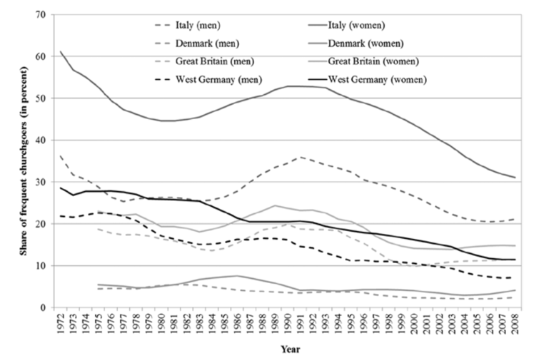
I argue that most of the change in the gender gap is the result of declining religiosity. Although modernization with regards to employment, education, and marriage certainly plays a role, the most important factor is religion. Historically, women have been more religious than men and religion is also a key determinant in vote choice (Emmenegger and Manow 2014). There are several theories about why women are traditionally more religious: they might have less material security because of gender inequality, needing religion for mental security; the social role of women was traditionally more tied to caregiving which is religious institutions reinforced and women were more socialized into obedience, modesty, and piety; and women historically had less autonomy and spent more time in the private sphere. The specific reason is not relevant to this essay, only that women were historically more religious, as shown in Figure 3 by looking at church attendance.
Figure 3: the share of frequent churchgoers in some Western democracies (Emmenegger and Manow 2014, 174)

The higher religiosity tied women to more Conservative and Christian Democratic parties and the anti-clericalism of left-wing parties made them off-limits for women. However, as society secularized (also at a faster rate among women), this religious-based voting declined. This way, religion and secularization are the main drivers behind the changing gender gaps in voting behaviour. Emmenegger and Manow (2014) find that once religiosity is controlled for, the gender gap largely disappears, though the other factors outlined above do still have a meaningful but limited effect. As a result, Christian Democratic parties, because women would vote for them anyway, could largely ignore the demands of women. But as religiosity declined, parties realigned, promoting welfare and family policies to attract female voters, such as CDU’s family policies under Merkel.

Radical Right Parties and elite polarization

However, the factors outlined above do not explain everything. For instance, the gender gap in voting behaviour for radical right parties is unusually large. Women should vote for those parties more than they do now, given their policy preferences. Harteveld and Ivarsflaten (2018) argue that this gender gap arises because women are more motivated than men to control prejudice, which interacts with party reputation. Whether a party is seen as toxic or has successfully distanced itself from racism influences the women vote. They argue that this is because women are more empathetic, have a greater interest in equality because of their own role in society, and reject hierarchal social structures. They find that the gender gap largely disappears when they control for this motivation of controlling prejudice. For instance, the British National Party is highly stigmatized and has a fascist legacy. On the other hand, the gender gap is much smaller for the Progress Party in Norway, which has a broader policy agenda, more moderate rhetoric, and distanced itself from extremism.

The factors above have also been criticised for not taking supply-side factors into account. Therefore, Shorrocks (2021) argues that many variations between countries and between elections in the same countries are the result of the electoral context. Furthermore, Gillion et al. (2020) argue that much of the gender gap in the United States is not the result of changing policy gender between the genders, but rather from ideological sorting in response to elite polarization. Between the 1960s and the 1990s, Democrats have moved left, and Republicans moved to the right. And as voters perceived these changes, they began sorting themselves into the party that matched their pre-existing policy preferences. This result is especially true for those highly educated voters, who recognized this polarization sooner.

In conclusion, the reversal of the gender gap in political attitudes and voting stems mainly from the decline female religiosity. As women secularized faster than men, their historical alignment with Christian and conservative parties weakened, allowing their egalitarian and welfare-oriented preferences to surface. Modernization through education, employment, and changing family structures reinforced this shift but played a secondary role.

Bibliography
Edlund, Lena, and Rohini Pande. 2002. ‘Why Have Women Become Left-Wing? The Political Gender Gap and the Decline in Marriage’. The Quarterly journal of economics 117(3): 917–61. doi:10.1162/003355302760193922.
Emmenegger, Patrick, and Philip Manow. 2014. ‘Religion and the Gender Vote Gap: Women’s Changed Political Preferences from the 1970s to 2010’. Politics & society 42(2): 166–93. doi:10.1177/0032329213519419.
Gillion, Daniel Q., Jonathan M. Ladd, and Marc Meredith. 2020. ‘Party Polarization, Ideological Sorting and the Emergence of the US Partisan Gender Gap’. British journal of political science 50(4): 1217–43. doi:10.1017/S0007123418000285.
Harteveld, Eelco, and Elisabeth Ivarsflaten. 2018. ‘Why Women Avoid the Radical Right: Internalized Norms and Party Reputations’. British journal of political science 48(2): 369–84. doi:10.1017/S0007123415000745.
Inglehart, Ronald, and Pippa Norris. 2003. Rising Tide: Gender Equality and Cultural Change Around the World. 1st edn New York: Cambridge University Press. doi:10.1017/CBO9780511550362.
Shorrocks, Rosalind. 2018. ‘Cohort Change in Political Gender Gaps in Europe and Canada: The Role of Modernization’. Politics & society 46(2): 135–75. doi:10.1177/0032329217751688.
Shorrocks, Rosalind. 2021. Women, Men, and Elections: Policy Supply and Gendered Voting Behaviour in Western Democracies. 1st ed. London ; Routledge.

What is gender
- Biological
- Social construct:
  - Probably better, as it is a lot a result of socialization.
  - Does not really matter statistically whether it is sex or gender.
  - For about a third, sex is a bad proxy for gender attitudes.

What is the gender gap
- Gap in voting
- Gap in attitudes
  - Salience vs values
- Gap in participation/turnout/descriptive representation
  - Women are underrepresented almost everywhere
  - Supply vs demand:
    - Supply: there’s fewer suitable women. Women don’t really put themselves forward, even if you control for all the other factors. Psychological effect, women don’t think that they will be good candidates, lack of political ambition. Why? Socialized norms, men more confident, women more modest; role models. Less highly educated wealthy women among party elites, possibly an issue with party recruitment. Parties have converged in this.
    - Demand: people are maybe less likely to vote for women, or at least parties think that they people won’t vote for them, which is probably not true, probably because people don’t really care about the gender.
    - Plateau, why?

- Gap in left-right identification
- Gap in religion:
  - Why is there this difference:
    - Security
    - Social roles
    - Autonomy
  - Why did it change:

Why all of this:
- Towards a service economy
- Technological change:
  - Washing machines
  - Anti-conception
  - These free up change

